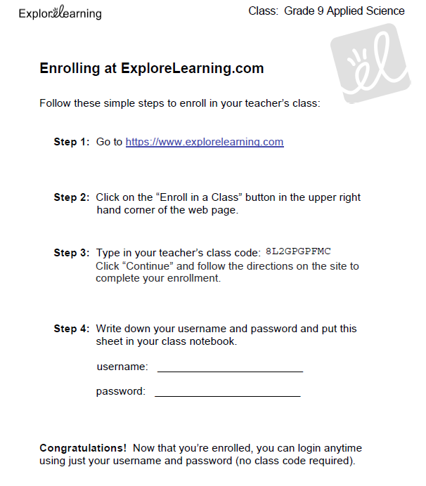

Name: ______________________________________ Date: ________________________

**Student Exploration: Density Laboratory**

**Vocabulary:** buoyancy, density, graduated cylinder, mass, matter, balance, volume

**Completion of Gizmo: Level: 4 3 2 1 R [Inquiry]**

**Calculations & Short Answers: Level: 4 3 2 1 R [Communication]**

***Full sentence answers, supporting details,***

***Accurate values, appropriate decimal places and units***

**Prior Knowledge Questions** (Do these BEFORE using the Gizmo.)

1. Of the objects below, circle the ones you think would float in water.

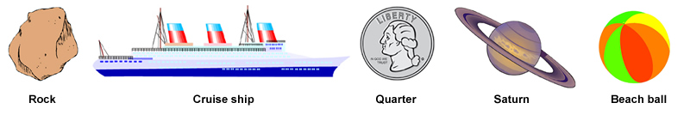

1. Why do some objects float, while others sink? ____________________________________

_________________________________________________________________________

**Gizmo Warm-up**

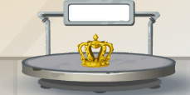The *Density Laboratory* Gizmo allows you to measure a variety of objects, then drop them in water (or other liquid) to see if they sink or float.

1. An object’s **mass** is the amount of **matter** it contains. Mass can be measured with a calibrated **balance** like the one shown in the Gizmo. Drag **Crown B** onto the balance.

What is the mass of **Crown B**?

1. 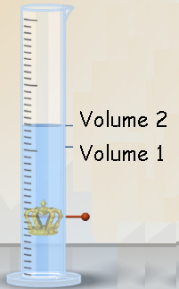An object’s **volume** is the amount of space it takes up. The volume of an irregular object can be measured by how much water it displaces in a **graduated cylinder**.
   1. What is the initial volume of water in the cylinder? (volume 1)
   2. Place **Crown B** into the cylinder.

What is the volume in the cylinder now? (volume 2)

* 1. What is the volume of **Crown B**?

Volume 2 – Volume 1:_______________________________ ___

**Note: While milliliters (mL) are used to measure liquid volumes, the equivalent unit cubic centimeters (cm3) are used for solids. Therefore, write the volume of Crown B in cm3.**

1. Calculate the Density of Crown B using the formula. Remember units!

Density = mass = ______ =

Volume

|  |  |  |
| --- | --- | --- |
| **Activity A:** | **Density** | DensityLaboratorySE3 |

**Question: How can you predict whether an object will float or sink?**

1. **Collect Mass and Volume data**: Experiment with the different objects in the Gizmo. Measure the mass and volume of each object (1-12) by placing them on the balance and in the graduated cylinder. Place each object back on the shelf when you are done.
2. **Calculate:** Calculate each object’s density.
3. **Predict data:** Predict if each object will SINK or FLOAT when it is placed in water.
4. **Test your predictions by placing each object in the large beaker of water to see if they sink or float!**

**Table 1: Mass, Volume and Density of Various Objects**

|  |  |  |  |  |  |
| --- | --- | --- | --- | --- | --- |
| **Object** | **Mass (g)** | **Volume (cm3)**  **Vol 2- Vol 1 = Volume of Objct** | **Density= Mass/Volume (g/cm3)** | **Prediction (Sink or float in water?)** | **Test if the object sinks or floats in the large beaker of water!** |
| 1 | 19.5 | 414.0-400.0= 14.0 | 19.5/14.0 =1.39 |  |  |
| 2 |  |  |  |  |  |
| 3 |  |  |  |  |  |
| 4 |  |  |  |  |  |
| 5 |  |  |  |  |  |
| 6 |  |  |  |  |  |
| 7 |  |  |  |  |  |
| 8 |  |  |  |  |  |
| 9 |  |  |  |  |  |
| 10 |  |  |  |  |  |
| 11 |  |  |  |  |  |
| 12 |  |  |  |  |  |
| **Crown A** |  |  |  |  |  |
| **Crown B** |  |  |  |  |  |
| **Crown C** |  |  |  |  |  |

1. **Analyze:** Compare the density of each object to the density of the water ( 1.0 g/mL).
   * 1. What do you notice about the density of the floating objects? _________________________________
     2. What do you notice about the density of the sinking objects? __________________________________
2. **Draw conclusions**: If you know the mass and volume of an object, how can you predict whether it will float or sink in water?

__________________________________________________________________________________

__________________________________________________________________________________

|  |  |  |
| --- | --- | --- |
| **Activity B:** | **The impact of Liquid Density on object Buoyancy** | DensityLaboratorySE4 |

**Question: How does liquid density affect whether objects float or sink?**

1. **Observe**: Place object 1 into the Beaker of liquid. Slowly move the Liquid density slider back and forth. What do you notice? ____________________________________________________________________

­­­­­­

1. **Hypothesize:** **Buoyancy** is the tendency to float. How do you think the liquid density affects the buoyancy of objects placed in the liquid? ___________________________________________________________________________

_________________________________________________________________________________

1. **Predict: In** the table below, write the density of each object. Then predict whether the object will float or sink in each of the fluids. Write “Float” or “Sink” in each empty box of the table.

|  |  |  |  |  |
| --- | --- | --- | --- | --- |
| **Object** | **Object density** | **Liquid density** | | |
| **0.5 g/mL** | **1.0 g/mL** | **2.0 g/mL** |
| 1 |  |  |  |  |
| 2 |  |  |  |  |
| 3 |  |  |  |  |
| 4 |  |  |  |  |
| 5 |  |  |  |  |

1. **Test:** Test your predictions using the Gizmo. Place a checkmark (\/) next to each correct prediction, and an “X” next to each incorrect prediction.
2. **Draw conclusions**: What is the relationship between the object density, the liquid density, and the tendency of the object to float?

____________________________________________________________________________________

____________________________________________________________________________________

**Application Question**: Gold is one of the densest metals (density 19.3 g/cm3). Most other metals have lower densities, in ancient times, the mathematician Archimedes was asked to determine if a crown was **pure gold**. Using the information from Table 1, determine which of the three crowns is made of gold. Explain your reasoning!

____________________________________________________________________________________

____________________________________________________________________________________